**Account # Deposit: $100 Connect: $100**

**SAM RAYBURN WATER, LLC**

**WATER SERVICE APPLICATION**

**P.O. BO/ 449**

**HUNTINGTON, TEXAS 75949**

**936-897-3102**

**APPLICANT** **CO-APPLICANT** **MAILING ADDRESS**

**PHYSICAL ADDRESS_______________________**

**CITY, STATE, ZIP**

HOME PHONE ______________ CELL PHONE ______________

**CONNECTION FEE is NON-REFUNDABLE**

**Type of Service (circle one): Residential Commercial Government RV Park Hotel/Cabin**

**Year built: __________ (if applicable)**

**PURPOSE: Sam Rayburn Water, llc is responsible for protecting the drinking water supply from contamination or pollution which could result from improper private water distribution system construction or configuration. The purpose of this service agreement is to notify each customer of the restrictions which are in place to provide this protection. The utility enforces these restrictions to ensure public health and welfare. Each customer must sign this agreement before Sam Rayburn Water, Inc. begins service. In addition, when service to an existing connection has been suspended or terminated, the water system will not re-establish service unless it has a signed copy of the agreement.**



**PURCHASED FROM: _____________________________________________**

**Notes: _______________________________________________________**

**RESTRICTIONS: The following unacceptable practices are prohibited by State Regulations.**

* 1. _No direct connections between the public drinking water supply and a potential source of contamination are permitted. Potential sources of contamination shall be isolated from the public water system by an airgap or an appropriate backflow prevention device.
  2. No cross-connection between the public drinking water supply and a private water system is permitted. These potential threats to the public drinking water supply shall be eliminated at the service connection by the installation of an airgap or a reduced pressure zone backflow prevention device.
  3. No connection which allows water to be returned to the public drinking water supply is permitted.
  4. No pipe or pipe fitting which contains more than .25% lead may be used for the installation or repair of plumbing at any connection which provides water for human use.
  5. No solder or flux which contains more than 0.2 % lead can be used for the installation or repair of plumbing at any connection which provides water for human use.
  6. Sam Rayburn Water has adopted the 2021 Uniform Plumbing Code.

**SERVICE AGREEMENT: The following are the terms of the service agreement between Sam Rayburn Water, LLC (the Water System) and (the Customer.)**

1. The Water System will maintain a copy of this agreement if the Customer and/or the premises is connected to the Water System
2. The customer shall allow his property to be inspected for possible cross-connections and other potential contamination hazards. These inspections shall be conducted by the Water System or its designated agent prior to initiating new water service; when there is reason to believe that cross-connections or other potential contamination hazards exist; or after any major changes to the private water distribution facilities. The inspections shall be conducted during the Water System's normal business hours.
3. The Water System shall notify the Customer in writing of any cross­ connection or other potential contamination which has been identified during the initial inspection or the periodic reinspection.
4. The customer shall immediately remove or adequately isolate any potential cross-connections or other potential contamination hazards on his premises.
5. The Customer shall, at his expense, properly install, test and maintain any backflow prevention device required by the Water System. Copies of all testing and maintenance records shall be provided to the Water System.
6. All water shall be metered by meters to be furnished and installed by Sam Rayburn Water, Inc. The meter and or connection is for the sole use of the Customer and is to serve water to only one dwelling or business and does not permit the extension of pipe or pipes to transfer water from one property to another, nor share, resell or submeter water to any other persons, dwelling, business, property, etc. General farm use is included with a dwelling or business, not irrigation use. Once set, meters are usable by Customers at that designated location and may not be transferred or relocated.

IV **ENFORCEMENT:** If the Customer fails to comply with the terms of the Service Agreement, the Water System shall, at its option, either terminate service or install, test, and maintain an appropriate backflow prevention device at the service connection. Any expenses associated with the enforcement of this agreement shall be billed to the Customer.

CUSTOMER'S SIGNATURE:

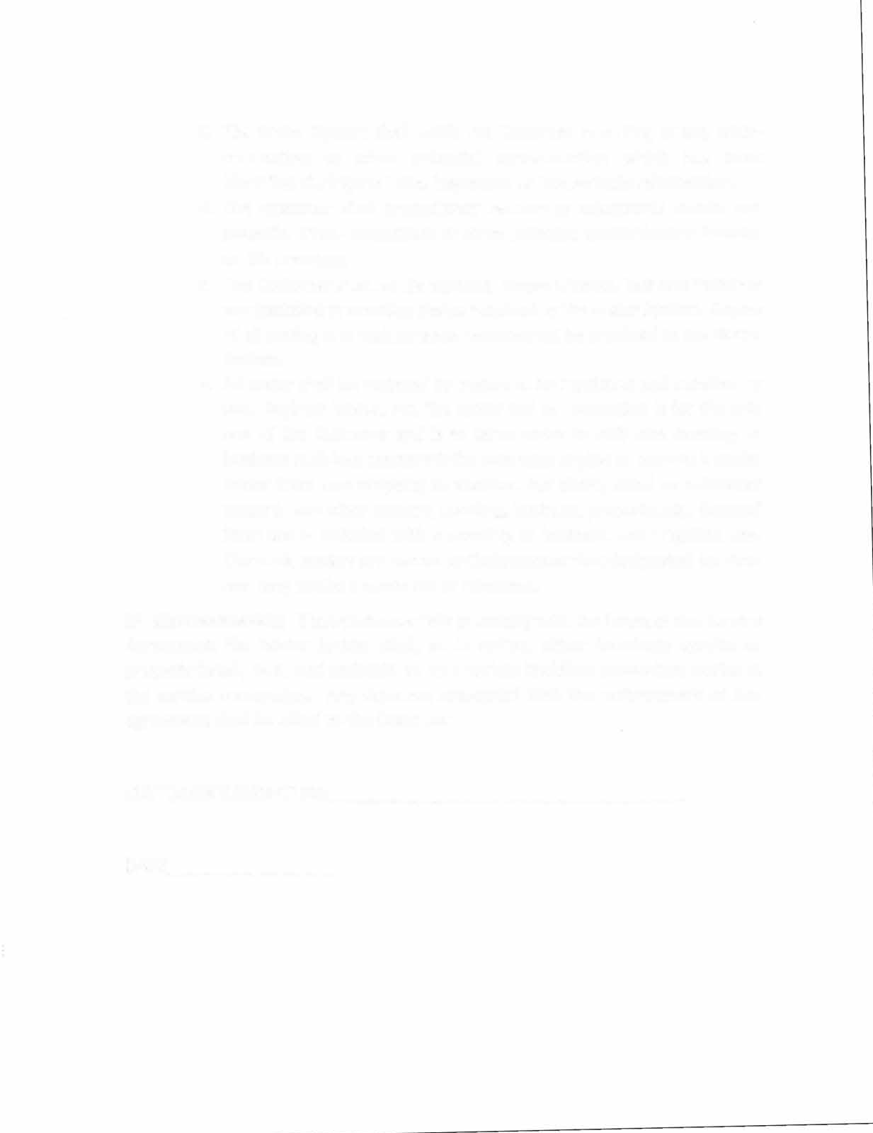DATE